**SECTION A (60 Marks)**

Answer only **three** questions from this section.

1. Some of the elements in the Period 3 of the Periodic Table are sodium, aluminium, silicon, phosphorus and chlorine.
2. Write the formulae of the oxide(s) of the each of the elements given above. (04 marks)
3. Describe the reaction(s) of the oxides of sodium, aluminium and phosphorus with water. In each case comment on the pH of the resultant solution. (05½ marks)
4. Write equation:
5. For the reaction between the oxides of aluminium and silicon with aqueous sodium hydroxide. (02 marks)
6. To show how the anhydrous chlorides of silicon and aluminium can be prepared. In each case state the condition(s). (04 marks)
7. Aluminium chloride was dissolved in water and to the resultant solution was added concentrated potassium hydrogen carbonate solution. State what was observed and explain your answer. (04½ marks)
8. (a) Explain what is meant by the following terms:

(i) Order of reaction (01 mark)

(ii) Molecularity of a reaction (01 mark)

(iii) Elementary reaction (01 mark)

(b) The following data was obtained for the reaction below;

$A_{2(g)}$ + ${2B}_{(g)}$ $2AB_{(g)}$

$∆H$ = -50 kjmol-1

|  |  |  |  |
| --- | --- | --- | --- |
| Experiment | [𝐴](𝑚𝑜𝑙𝐿−1) | [𝐵](𝑚𝑜𝑙𝐿−1) | Initial rate (𝑚𝑜𝑙𝐿−1𝑠−1) |
| 1 | 0.03 | 0.03 | 0.3×10−4 |
| 2 | 0.06 | 0.06 | 1.2×10−4 |
| 3 | 0.06 | 0.09 | 2.7×10−4 |

1. State the order of reaction with respect to $A_{2}$ and ***B***. Give reasons for your answer (02marks)
2. Write the rate equation for the reaction. (01 mark)
3. Calculate the rate constant and its units. (02 marks)
4. Draw a labeled energy diagram for the reaction in (b) above (activation energy Ea =+250 kjmol-1, enthalpy change) (03 marks)
5. Calculate the activation energy for the backward reaction.(01 mark)
6. Explain the effect of increasing temperature for the above reaction on; (03 marks)
7. Equilibrium constant.
8. Position of equilibrium.
9. Rate of reaction.
10. Draw a sketch graph to show the change in concentration of **AB** with time at a given temperature. (02 marks)

1. A compound Q contains carbon, hydrogen and nitrogen only and burns with a sooty flame. On complete combustion, 2.325g of Q yields 3.36 liters at of carbon dioxide at s.t.p and 295.5 cm3 of nitrogen gas measured at 15 $℃$ and 1 atmosphere.
2. Calculate the empirical formula of compound, Q. (06 marks)
3. When Q was steam distilled at 98 $℃$ and 760mmHg, the distillate contained 45.49 % by mass of Q (the saturated vapour pressure of water at this temperature is 655mmHg).
4. Determine the molecular formula of compound, Q. (03 marks)
5. Write the structural formula of compound, Q. (01 mark)
6. When Compound Q was treated with sodium nitrite solution and concentrated hydrochloric acid in a boiling tube kept at $0℃$, compound R was formed to which hydroxy benzene was added in presence of sodium hydroxide solution.
7. Write the equation for the reaction leading to formation of compound R. (02 marks)
8. State what is observed when hydroxy benzene was added to compound R in presence of sodium hydroxide and write the equation for the reaction. (02 marks)
9. Without equations describe how:
10. Compound Q can be converted to nitrobenzene. (03 marks)
11. Compound Q can be synthesized from benzene sulphonic acid. (03 marks)
12. Explain each of following observations;
13. When propanone was mixed with trichloromethane, a warm miscible mixture was formed whose volume was lower than the sum of the volumes of the individual components. (04 marks)
14. Methanoic acid forms a silver mirror with Tollen’s reagent while ethanoic acid gives no observable change. (04 marks)
15. Hydrofluoric acid is a weak acid but its strength increases with increase in concentration. (05marks)
16. A mixture of benzene (boiling point 80 $℃$) and water (boiling point 100 $℃$) boils at a temperature of 70 $℃$ (03 marks)
17. Phenyl amine is a weaker base than Ethyl amine (04 marks)

**SECTION B (40 Marks)**

Answer only **two** questions from this section.

1. (a).Using suitable examples explain what is meant by the terms:
2. Salt hydrolysis. (02 marks)
3. Acidic buffer solution. (02 marks)
4. Explain why it’s not advisable to use soap solutions to wash aluminium utensils. (03 marks)
5. The pH readings below refer to the titration of sodium hydroxide solution against 25cm3 of 0.1M ethanoic acid.

|  |  |  |  |  |  |  |  |  |  |  |  |
| --- | --- | --- | --- | --- | --- | --- | --- | --- | --- | --- | --- |
| Volume of  (cm3) | 0 | 4 | 8 | 12 | 16 | 20 | 22 | 22.5 | 23 | 24 | 28 |
| pH of the mixture | 2.8 | 3.5 | 4.0 | 4.5 | 5.1 | 5.8 | 7.0 | 9.0 | 10.5 | 11.4 | 12.3 |

1. Plot a graph of pH against volume of sodium hydroxide. (03 marks)
2. Explain the shape of the curve. (03 marks)
3. Determine the PH at end point. (01 mark)
4. Calculate the molarity of sodium hydroxide solution. (02 marks)
5. Determine the dissociation constant, Ka of ethanoic acid used. (04 marks)
6. Write the equation to show how the following compounds can be synthesized and in each case outline a mechanism leading to formation of the major product.
7. Benzene sulphonic acid from benzene (03 $\frac{1}{2}$ marks)
8. 1-bromopropane from propene (03 marks)
9. 2-methylpropan-2-ol from 2-chloro-2-methylpropane (02 $\frac{1}{2}$ marks)
10. Propyne from bromomethane (01 $\frac{1}{2}$ marks)
11. $HCOO{CH}_{2}{CH}_{3}$ from ethanol (05 marks)

$$C=N-{NH}_{2}$$

$$H$$

from phenylmethanal (04 $\frac{1}{2}$ marks)

1. The most important ore of copper is copper pyrites.
2. (i) Write down the formula of copper pyrites. (01mark)

(ii) Describe concisely how pure copper can be extracted from copper pyrites (write equations for the reactions that take place). (12 marks)

1. (i) Explain why sulphuric acid manufacturing plants are constructed near copper extraction plants. (01 $\frac{1}{2}$ marks)
2. Using equations only show how sulphuric acid is manufactured by the contact process. (03 marks)
3. State what is observed and write equation(s) for the reaction that takes place when excess concentrated hydrochloric acid is added to copper (II) sulphate solution followed by dilution with water. (02 $\frac{1}{2}$ marks)
4. Using relevant examples differentiate between each of the following terms:
5. Thermo softening and Thermosetting plastics. (03 marks)
6. Condensation and addition polymers . (03 marks)
7. Natural rubber is a natural polymer while Nylon 6, 10 is an artificial polymer.
8. Write the structural formulae of each of the polymers named in (b) above. (02 marks)
9. Suggest the structure(s) and IUPAC name(s) of the monomer(s) of the polymers named in (b) above. (04 marks)
10. (i)Briefly explain how the properties of natural rubber can be improved (03 marks)
11. State two uses of the product obtained in c (i). (01 mark)
12. (i) The osmotic pressure of a solution containing 2gdm-3 of nylon 6, 10 at 25 $℃$ was 0.155mmHg. Calculate the relative molecular mass of nylon6, 10. (03 marks)
13. State two uses of nylon 6, 10 (01 mark)

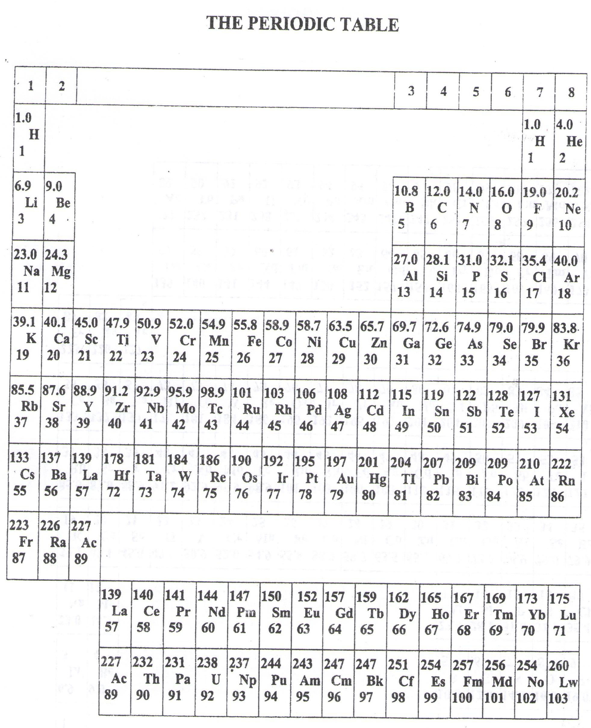

* ===END===

WELCOME TO SENIOR SIX, YEAR 2023

This is the last page of the printed paper, Page 05